Exercise 1 – Neural Networks

$a=\sum_{i=1}^{n}{w_{i}x_{i}}$

$$a=w_{1}x_{1}+w_{2}x_{2}+w_{3}x_{3} \\ a= 0.2 × 1 + (-1) × 0 + 0.5 × 1$$

$$a=0.2+0+0.5$$

The activation is $a=0.7$



$y=$ $\left\{\begin{aligned}1, a≥h \\ 0, a<h\end{aligned}\right.$

$a=0.7 >h=0. 5$ The output is $y= 1$

1. $a=0.7 <h=0.8 \overset{⇒}{ }$ The output is $y=0$

$a=-0.2<h=0.5\overset{⇒}{ }y=0$

$$w_{1}^{'}=w_{1}+α\left(t-y\right)x_{1}=0.1 \\ w_{2}^{'}=w_{2}+α\left(t-y\right)x_{2} \\ w_{2}^{'}= -1+0.1\left(1-0\right)×0 \\ w_{2}^{'}=-1 \\ w_{3}^{'}=w_{3}+α\left(t-y\right)x_{3} \\ w_{3}^{'}=0.5+0.1\left(1-0\right)×0 \\ w_{3}^{'}=0.5$$

${\vec{w}}^{'}=〈0.1, -1, 0.5〉$

* Pattern p2:
* Pattern p3:
* Pattern p4:

1. The learning does not change the weight vector for pattern p4 because the target output of the pattern is $t=0$ and the output $y=0$, therefore the update equation would become:

$$w_{i}^{'}=w_{i}+∝\left(t-y\right)x_{i} \overset{⇒}{ } w_{i}^{'}=w_{i}+∝\left(0-0\right)x_{i} \overset{⇒}{ }w_{i}^{'}=w_{i}+∝×0×x_{i} \overset{⇒}{ } w_{i}^{'}=w_{i}+0 \\ \overset{⇒}{ }w_{i}^{'}=w_{i}$$

As a result, the weight vector for pattern p4 is the same as the wieght vector for pattern p3.

1. Yes.
2. Initial Test Error: 1.0211

|  |  |  |  |  |  |  |  |  |  |  |
| --- | --- | --- | --- | --- | --- | --- | --- | --- | --- | --- |
| Test no | Initial $w_{1}$ | Initial $w_{2}$ | Final $w_{1}$ | Final $w_{2}$ | Correct test ex (50) | Correct test ex (100) | Correct test ex (150) | Correct test ex (200) | Correct test ex (250) | Correct test ex (300) |
| 1 | 0.5 | 0.21 | 0.09 | 0.06 | 50% | 50% | 50% | 50% | - | - |
| 2 | 0.95 | -0.61 | 0.01 | -0.03 | 50% | 50% | 50% | 50% | 50% | 50% |
| 3 | 0.29 | -0.01 | 0.0 | -0.01 | 50% | 50% | 50% | 50% | 50% | 50% |
| 4 | -0.86 | 0.71 | -0.02 | 0.03 | 75% | 75% | 50% | 50% | 50% | 50% |
| 5 | 0.38 | 0.37 | 0.04 | 0.04 | 25% | 25% | 25% | 25% | 25% | 25% |

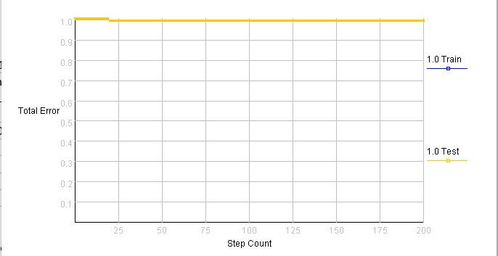

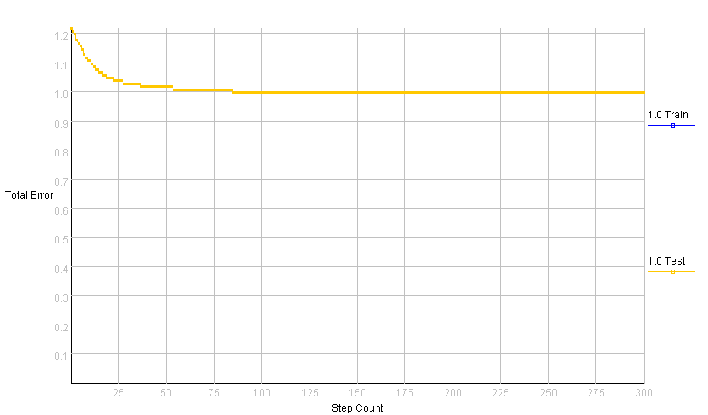

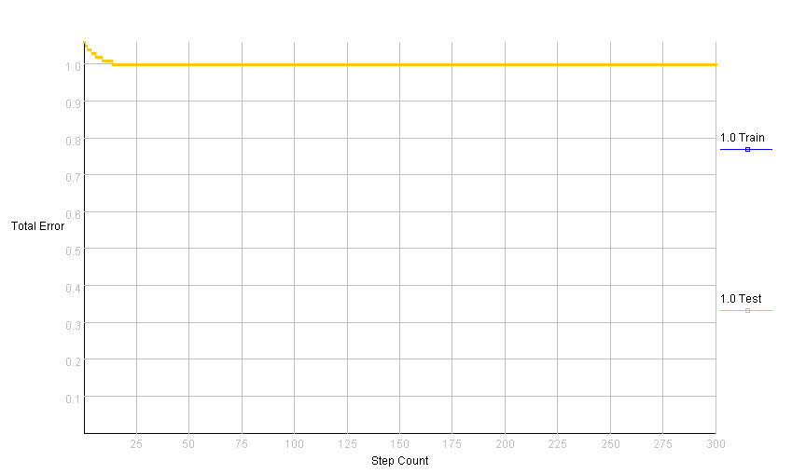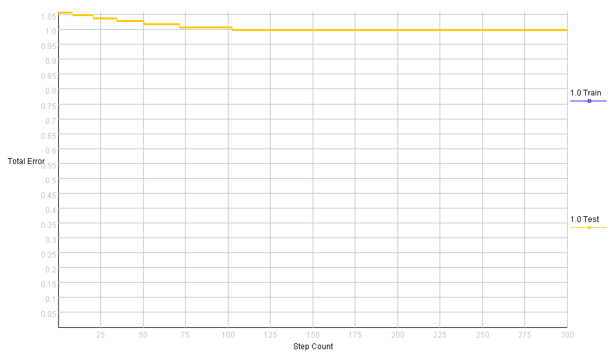

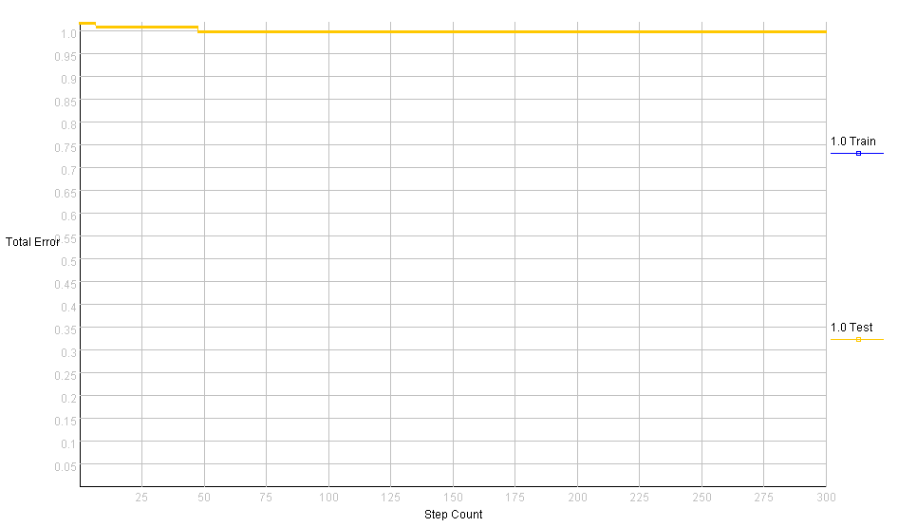

1. The single neuron doesn’t converge to classify all test patterns correctly
2. XOR is not a linearly separable problem.
3. The network won’t solve XOR.
4. The network that solves XOR:

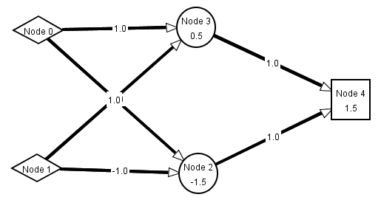

Trial 1 (weights and steps):

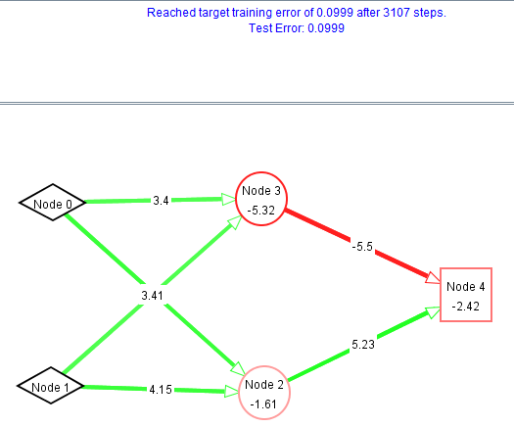

Trial 1 (error graph):

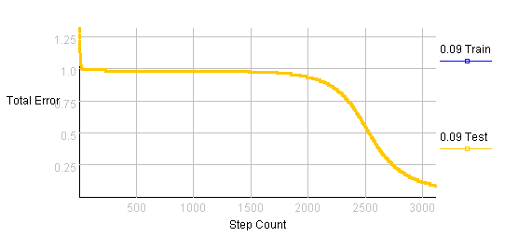

Trial 2 (weights and steps):

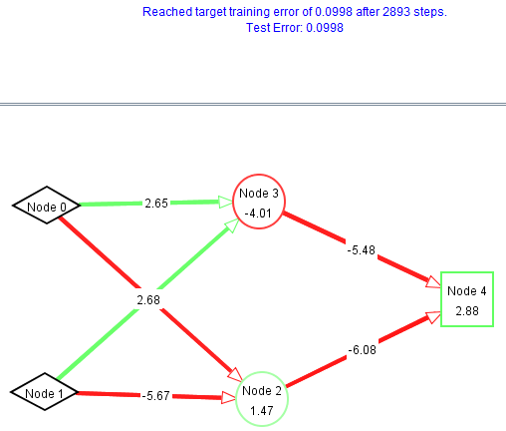

Trial 3 (weights and steps):

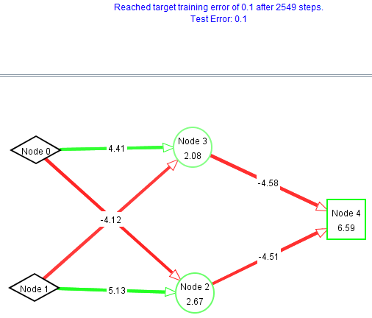

Trial 3 (error graph):

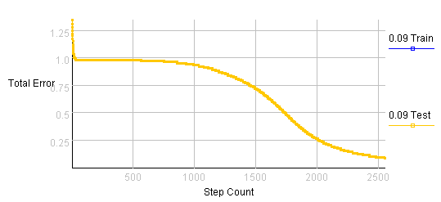

Trial 4 (weights and steps):

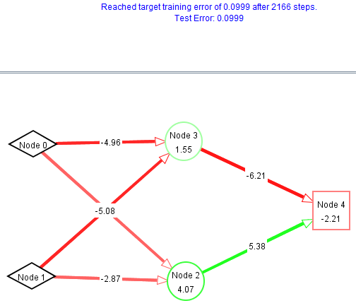

Trial 5 (weights and steps):

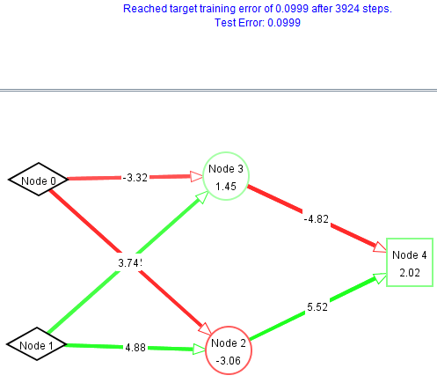

Trial 5 (error graph):

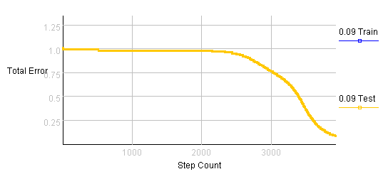

Trial 6 (weights and steps):

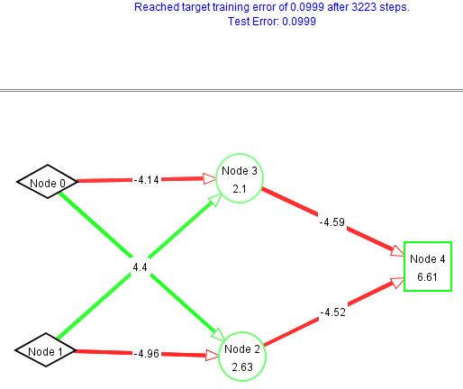

Trial 7 (weights and steps):

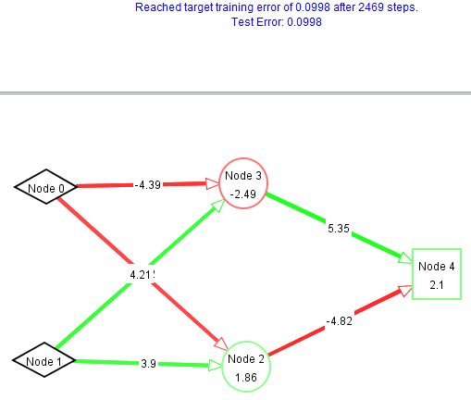

Trial 7 (error graph):

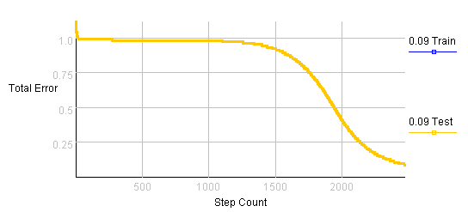

Trial 8 (weights and steps):

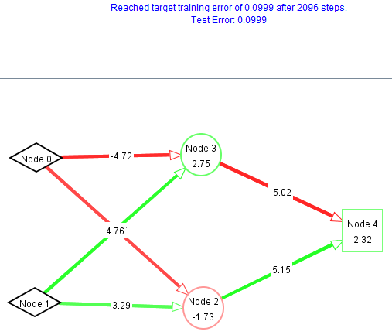

Trial 9 (weights and steps):

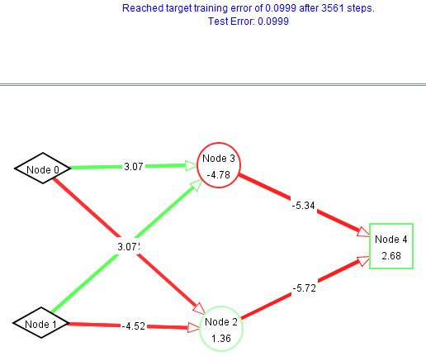

Trial 9 (error graph):

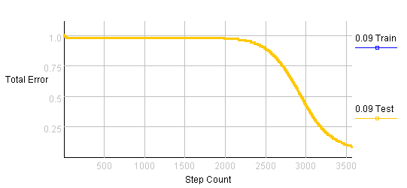

Trial 10 (weights and steps):

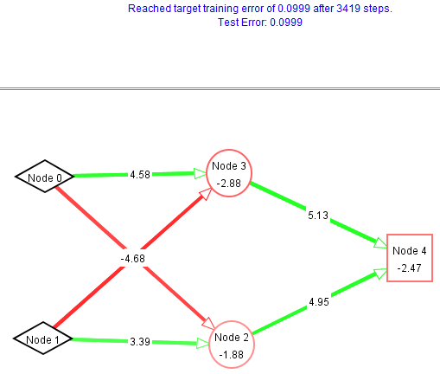

1. What do you notice about the error on different trials. Explain your observations.

Each trial stops at a different number of steps. Some trials fail to stop before 50,000 steps.